<A BIDV based Smart Banking app>

Version <1.0>

Revision History

|  |  |  |  |
| --- | --- | --- | --- |
| **Date** | **Version** | **Description** | **Author** |
| <dd/mmm/yy> | <x.x> | <details> | <name> |
| <29/11/2022> | <1.0> | <Complete the requirement> | <Lai Trang> |
|  |  |  |  |
|  |  |  |  |

Table of Contents

1. Introduction 2

1.1 Purpose 2

1.2 Scope 2

1.3 Definitions, Acronyms, and Abbreviations 2

1.4 References 2

1.5 Overview 2

2. Flow of Events—Design 2

3. Derived Requirements 2

# Introduction

## Purpose

This document describes the process of paying with QR codes of BIDV Smart Banking application on smartphones. This process will be clarified via Derived requirements and Flow of events – Design (design model, sequence diagram and class diagram)

## Scope

This document conducts paying with QR codes function on smartphone app for BIDV system

## Definitions, Acronyms, and Abbreviations

User: the customer who uses BIDV Smart Banking service

App: BIDV Smart Banking application provides on Google play or App store

GUI system: Graphic user interface shows interfaces to the end-user

Controller: provides for users input and modifications

Model: database includes user’s account number, password….

## References

None

## Overview

Paying with QR codes in BIDV Smart Banking system will be summarized as follows, firstly, there are 2 diagrams we need to complete includes sequence diagram and class diagram, which is used to describe how the use-case is conducted. Last but not least, the derived requirement’s part is a textual description that collects all requirements, such as non-functional requirements, on the use-case realizations not considered in the design model, but that need to be taken care of during implementation

# Flow of Events—Design

## sequence diagram

## class diagram

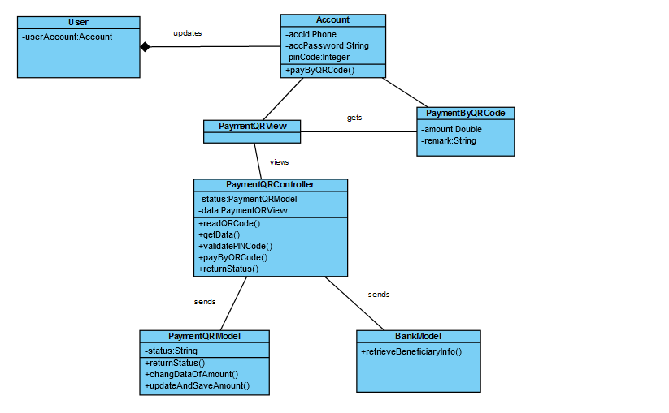

# Derived Requirements

3.1 If the system does not get any respond from user for an allotted time, the system asks user to login again because of his/her login session expiring

3.2 If user enters the wrong PIN code, the system asks user to re-enter

3.3 If users input the amount of money is greater than the available balance, the system asks user to re-enter